Step 1:
Create New ASP.NET Empty Web Application
Templates -> Web -> Visual Studio 2012 -> ASP.NET Empty Web Application
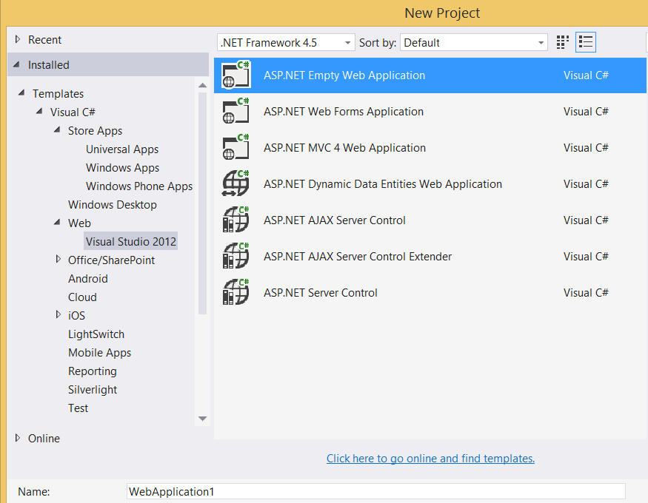

Step 2: Add New WebForm Page
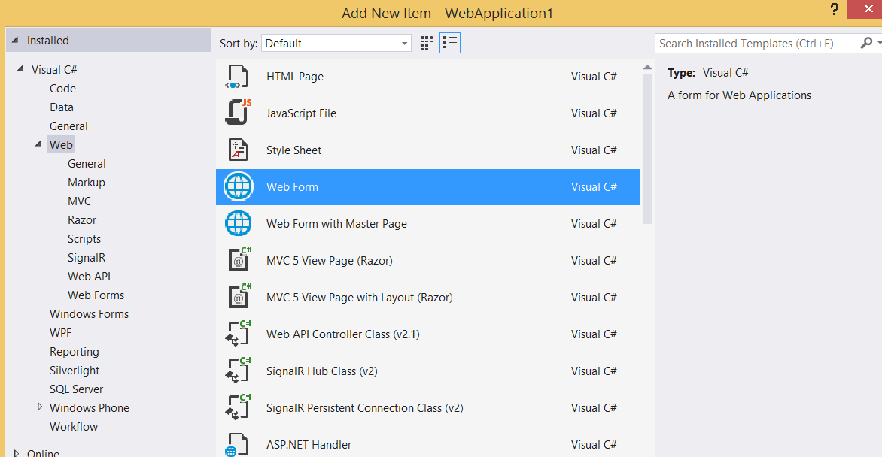

Step 3:
Add one button & file upload control in WebForm1.aspx page

<body>
<form id="form1" runat="server">
<div>
Photo Upload : <asp:FileUpload ID="fuTest" runat="server" />
<br/>
<asp:Button ID="btnUpload" Text="Upload File" runat="server" OnClick="btnUpload_Click"/>
<asp:Label ID="lblPhotoUpload" Text="Click on Upload File button" runat="server" />
</div>
</form>
</body>

Step 4:
Right click on project name and select “Manage NuGet Packages…”
Search for “Azure Storage”

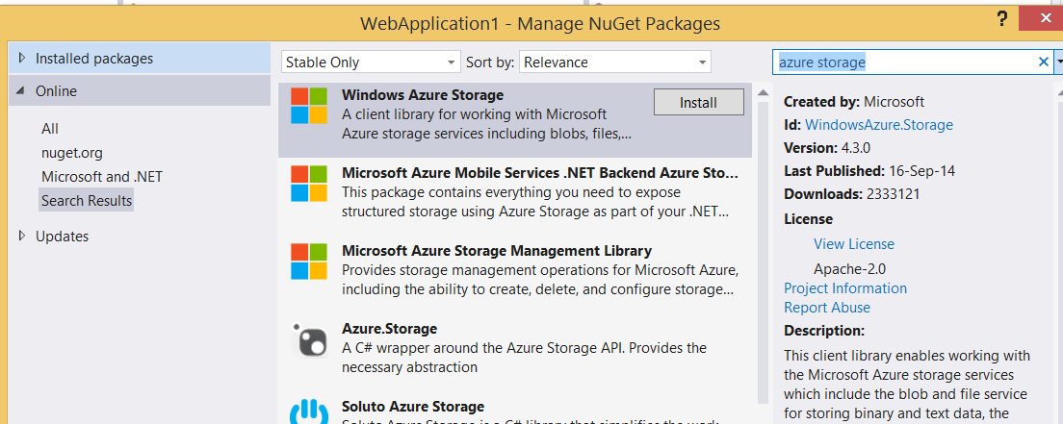

Install the Package.

Step 5:
Open WebForm1.aspx.cs
Add the reference of Azure storage
using Microsoft.WindowsAzure.Storage;
using Microsoft.WindowsAzure.Storage.Auth;
using Microsoft.WindowsAzure.Storage.Blob;

protected void Page_Load(object sender, EventArgs e)
{

}

protected async void btnUpload_Click(object sender, EventArgs e)
{
// Retrieve storage account from connection string
CloudStorageAccount storageAccount = new CloudStorageAccount(
new StorageCredentials("storagename",
"storageaccesskey"), true);

// Create the blob client
CloudBlobClient blobClient = storageAccount.CreateCloudBlobClient();

// Retrieve reference to a previously created container
CloudBlobContainer container = blobClient.GetContainerReference("photocontainer");
await container.CreateIfNotExistsAsync();

CloudBlockBlob blockBlob = container.GetBlockBlobReference(fuTest.PostedFile.FileName);

// Create or overwrite the "myblob" blob with contents from a local file.
using (var fileStream = fuTest.PostedFile.InputStream)
{
blockBlob.UploadFromStream(fileStream);
}

lblPhotoUpload.Text = "Photo Uploaded Successfully.";

}

Now run the project



Image successfully uploaded

Using Azure Storage Explorer

